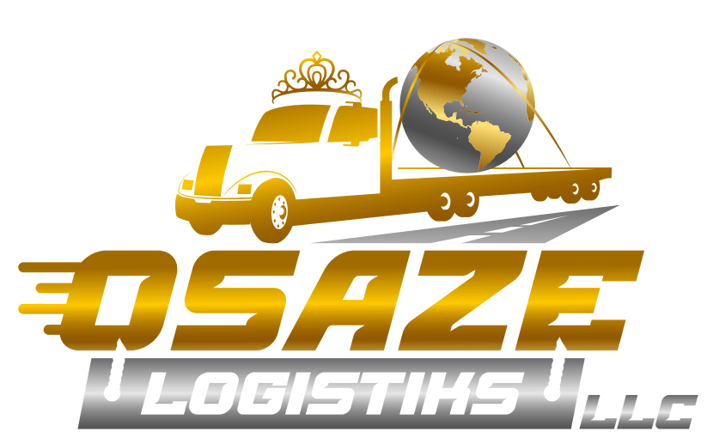

Service Level Agreement for Compliance Services

RECITALS
This Service Level Agreement (SLA) made as of this _________day of _______________, 2024, by and between Osaze Logistiks LLC hereinafter referred to as ("Service Provider") and ___________________________ (Name) of ____________________________________(Company Name) hereinafter referred to as Client to establish the terms and conditions for the provision of trucking compliance services.

Whereas Client is a Carrier/Owner Operator, desiring to retain Osaze Logistiks LLC for trucking compliance services.

Whereas Osaze Logistiks LLC is a service provider ensuring that the Client adheres to all relevant regulations and industry best practices.

The Client must prior to the implementation of this agreement, furnish to Osaze Logistiks the following:

  - A copy of Client’s Certificate of Authority.
  - Proof of Insurance Certificates.
  - This Agreement for Compliance Services form completed, signed, and dated.
  - Company Profile Completed.

- STATEMENT OF WORK

Osaze Logistiks will:
- Monitor and ensure compliance with local, state, and federal trucking regulations of Client’s Company are always in compliance.
- Conducting audits and inspections to identify any non-compliance issues.
- Providing assistance and guidance to the Client in implementing corrective actions and maintaining compliance.
- Offering training programs and resources to enhance the Client's understanding of trucking compliance requirements.
- Assign qualified and experienced personnel to perform the trucking compliance services.
- Adhere to all applicable laws, regulations, and industry standards.
- Deliver services in a professional and timely manner.
- Provide accurate and comprehensive reports and documentation.
- Maintain the confidentiality and security of any information obtained during service delivery.

A. Obligation of Service Provider
- Conduct regular compliance assessments to identify any areas of non-compliance.
- Provide detailed reports outlining findings, recommendations, and suggested corrective actions.
- Assist in developing and implementing compliance strategies and policies.
- Deliver training sessions and educational materials to the Client's staff regarding trucking compliance best practices.
- Maintain up-to-date knowledge of relevant trucking regulations and inform the Client of any changes that may impact their operations.

B. Obligation of Client
  - Cooperate with the Service Provider and provide all necessary information and access to facilities and records for the purpose of delivering the services.
  - Notify the Service Provider promptly of any changes in their operations or relevant regulations that may affect compliance.
  - Implement any recommended corrective actions in a timely manner.
  - Assign a designated point of contact for communication with the Service Provider.

3. Osaze Logistiks Objectives

Keeping the out-of-service (OOS) rate below the national average is crucial for trucking companies to maintain compliance, ensure safety, and preserve their reputation in the industry. Here are several strategies to achieve this:

- Preventive Maintenance Programs: Implement a robust preventive maintenance program for all vehicles in your fleet. Regular inspections and maintenance checks help identify and address potential issues before they escalate, reducing the likelihood of OOS violations during roadside inspections.
- Driver Training and Education: Provide comprehensive training and education programs for drivers on compliance with regulations, proper vehicle maintenance procedures, and safe driving practices. Well-trained drivers are more likely to identify and rectify potential violations, contributing to a lower OOS rate.
- Compliance Monitoring Systems: Utilize advanced technology solutions, such as electronic logging devices (ELDs) and fleet management software, to monitor compliance in real-time. These systems can track drivers' hours of service, vehicle maintenance schedules, and compliance with regulatory requirements, allowing for proactive intervention to address potential violations.
- Regular Vehicle Inspections: Conduct regular vehicle inspections to ensure compliance with safety standards and regulations. Implement thorough pre-trip and post-trip inspection procedures and empower drivers to report any safety concerns promptly. Addressing maintenance issues promptly can prevent OOS violations during roadside inspections.
- Driver Performance Monitoring: Monitor driver performance metrics, such as driving behavior, adherence to speed limits, and compliance with traffic laws. Identify any patterns of non-compliance or unsafe driving practices and provide targeted training and coaching to improve driver behavior and reduce the risk of OOS violations.
- Compliance Audits and Reviews: Conduct regular compliance audits and reviews to assess adherence to regulations and identify areas for improvement. Review driver logs, vehicle maintenance records, and inspection reports to identify any potential compliance issues and take corrective action as needed.
- Partnership with Regulatory Agencies: Foster positive relationships with regulatory agencies, such as the Federal Motor Carrier Safety Administration (FMCSA) and state enforcement authorities. Stay informed about changes to regulations and proactively address any compliance concerns raised during inspections or audits.
- Continuous Improvement Culture: Foster a culture of continuous improvement within the organization, where compliance and safety are top priorities. Encourage open communication, feedback, and collaboration among drivers, dispatchers, and management to identify and address potential compliance issues proactively.
  - By implementing these strategies, trucking companies can reduce their out-of-service rates and maintain compliance with regulatory requirements, ensuring the safety of drivers, vehicles, and the public while preserving their reputation in the industry.

4. Performance Measurement and Reporting
Osaze Logistiks will:
- Measure and report the compliance rate and other relevant performance indicators as outlined in this SLA.
- Provide periodic reports to the Client, detailing the results of compliance assessments, recommendations, and actions taken.
- Address any performance issues promptly and work with the Client to resolve them.

5. Service Availability and Response Time
The Service Provider will be available to respond to inquiries and provide assistance during regular business hours [specify hours]. Emergency support will be available only if a client has received tickets or OOS situations.

6. Compliance and Legal Requirements
The Service Provider agrees to comply with all relevant local, state, and federal trucking regulations and maintain any necessary licenses, permits, or certifications required for the provision of the services.

7. Confidentiality and Data Security
Both parties agree to maintain the confidentiality of any proprietary or sensitive information shared during the provision of services. The Service Provider will implement appropriate data security measures to protect the Client's information from unauthorized access or disclosure.

8. Service Termination and Exit Strategy
Either party may terminate this SLA upon [30] days written notice for any reason. In the event of termination, the Service Provider will cooperate with the Client to facilitate the transition of services to another provider or assist in any other necessary arrangements.

9. Review and Amendment
This SLA will be reviewed annually or as otherwise mutually agreed upon by both parties. Any amendments to this SLA must be made in writing and signed by authorized representatives of both parties.

Hold Harmless Clause
The Client agrees to hold harmless and indemnify the Trucking Compliance Provider, its officers, employees, agents, and representatives (collectively referred to as the "Provider"), from any claims, damages, losses, liabilities, costs, or expenses (including reasonable attorney fees) arising out of or related to the services provided by the Provider, except to the extent caused by the Provider's gross negligence or willful misconduct.

The Client acknowledges that the services provided by Osaze Logistiks are advisory in nature and that the ultimate responsibility for compliance with all trucking regulations and legal requirements rests with the Client. The Client assumes all risks associated with non-compliance, including but not limited to fines, penalties, and any legal consequences.

The Client agrees to defend, indemnify, and hold Osaze Logistiks harmless from and against any claims, demands, suits, or actions brought by third parties arising from or in connection with the Client's use of the Provider's services, including but not limited to claims for personal injury, property damage, or violations of any applicable laws or regulations.

The Client further acknowledges that the Osaze Logistiks is not liable for any indirect, incidental, special, or consequential damages, including but not limited to lost profits, business interruption, or loss of data, arising out of or in connection with the services provided, even if the Provider has been advised of the possibility of such damages.

This “Hold Harmless Clause” shall survive the termination or expiration of the agreement between the Provider and the Client.

By utilizing the services of Osaze Logistiks, the Client acknowledges and agrees to the terms of this hold harmless clause."

By signing below, the parties acknowledge that they have read, understood, and agreed to the terms and conditions outlined in this Service Level Agreement.

Osaze Logistiks LLC
Printed Name: ______________________
Signature: ______________________
Date: __________________________

Client Company Name
Printed Name: ______________________
Signature: ______________________
Date: __________________________

